

milestone report

internal project report

Project code: RnD4Profit-15-02-016 Phosphorus efficient pastures
Prepared by: Doug Alcock
Graz Prophet Consulting
Date published: 29 September 2016

PUBLISHED BY
Meat and Livestock Australia Limited
Locked Bag 1961
NORTH SYDNEY NSW 2059
Phosphorus Efficient Pastures:
delivering high nitrogen and water use efficiency, and reducing cost of production across southern Australia
Activity B5. Extending the adaptation range of serradella systems
Milestone 1. 1 October 2016
Meat & Livestock Australia acknowledges the matching funds provided by the Australian Government to support the research and development detailed in this publication.
This publication is published by Meat & Livestock Australia Limited ABN 39 081 678 364 (MLA). Care is taken to ensure the accuracy of the information contained in this publication. However MLA cannot accept responsibility for the accuracy or completeness of the information or opinions contained in the publication. You should make your own enquiries before making decisions concerning your interests. Reproduction in whole or in part of this publication is prohibited without prior written consent of MLA.
Abstract

Potential host farms for the Monaro based participatory research component have been identified using existing MFS soils club soil test data. 4 potentially suitable farm paddocks were identified and at least two sites (differing in slope, aspect or elevation) soil sampled for additional screening for suitability.
On the basis of soil P status two farms have been shortlisted for additional soil testing of additional nutrients. Pending the results of the additional testing the sites will have an initial spray treatment applied in October to kill existing vegetation and prevent seeding of weeds this spring.

Table of Contents

1 Milestone description 4
1.1 Key Performance Indicator(s) 4
2 Materials and Methods 4
2.1 Heading (e.g. Experiment 1) 4
2.1.1 Sub heading (e.g. Site and soil type) 4
2.2 Heading (e.g. Experiment 2) 4
2.2.1 Sub heading (e.g. Site and soil type) 4
3 Success in meeting the milestone 4
3.1 Results 4
3.1.1 Sub heading 4
3.1.2 Sub heading 4
3.2 Discussion 5
3.2.1 Sub heading 5
4 Conclusions/recommendations 5
4.1 Heading 5
4.1.1 Sub heading 5
5 Communications 5
5.1 Heading 5
5.1.1 Sub heading 5
6 Bibliography (optional) 5
7 Appendix (optional) 6
7.1 Heading 6
7.1.1 Sub heading 6

Milestone description

Key Performance Indicator(s)
Two 'Farm Group participatory' research sites selected and weed control plan in place.

Materials and Methods

Participatory Research Site 1

Site and Soil Type
A suitable site has been identified on the property Glen Finnan. The soil at this site is derived predominantly from the typical slate/shale association that crosses the Monaro and is a soil type that represents around a third of the arable area in the region.
Soil P levels have been tested and demonstrate the sites selected are around 60% and 30% of critical levels for clover growth respectively allowing a good test of serradella performance in sub optimal soil P levels
 | Colwell P | Olsen P | PBI | PBI | predicted critical Colwell for clover
 | mg/kg | mg/kg | colwell | unadjusted | predicted critical Colwell for clover
Glen Finnan North Creek A | 18.1 | 11.4 | 49.6 | 46.5 | 29
Glen Finnan North Creek A POA | 18.6 | 10.8 | 51.3 | 48.1 | 29
Glen Finnan North Creek B | 9.66 | 5.6 | 53.0 | 51.3 | 29
Glen Finnan North Creek B (duplicate of above sample) | 8.60 | 6.4 | 53.2 | 51.7 | 29
Results of the full soil test are pending.

Participatory Research Site 2

Sub heading (e.g. Site and soil type)
A suitable site has been identified on the property Redcliff. The soil at this site is also derived predominantly from the typical slate/shale association that crosses the Monaro.
Soil P levels have been tested and demonstrate the sites selected are only around a third of the critical levels for clover growth. Additional fertiliser will likely be required to boost the soil P to around 2/3 of critical levels while still allowing a good test of serradella performance in sub optimal soil P levels
 |  |  |  |  | predicted critical Colwell for clover
 | Colwell P | Olsen P | PBI | PBI | predicted critical Colwell for clover
 | mg/kg | mg/kg | colwell | unadjusted
Redcliff windy East | 10.8 | 5.1 | 70.3 | 68.4 | 31
Redcliff windy South | 5.80 | 2.9 | 69.4 | 68.4 | 31
Redcliff windy West | 12.1 | 5.2 | 101 | 98.6 | 33

Results of the full soil test are pending.

Success in meeting the milestone

Results

Site selection
Potential participatory research sites were identified using soil test data derived from and provided by the MFS soils club data base. In addition there was a call to all members for interest in the project. 5 potential paddocks were offered by farmer MFS members and only one site was excluded as unsuitable due to the relatively high soil P status already prevailing (basalt derived soil)
Four sites were surveyed (see map at appendix 7.1) and soil samples taken in accordance with the site selection protocols supplied by Graminus Consulting (Jim Virgona) Two sites were located in the vicinity of Cooma in the northern part of the region and two located near Bombala in the south.
Soil test data suggested three of the four sites tested to be at or below thr desired maximum soil P level. The site at Hazeldean being close to critical P levels.
Based on soil test, location, access and topography the two sites currently being progressed are the property of Owen Smith “Glen Finnan”, Dry Plains via Cooma and Ned Kater “Redcliff” west of Bombala.
Having a site in the north and one in the south is seen as desirable with regard to producer engagement with communications activities. The sites also differ in elevation which can have a major impact on climate in this district. Both sites have average annual rainfall in the order ot 600mm.
The two producers have been contacted to begin the process of site preparation this spring. Initial weed control will be done in October 2016 and a plan for following herbicide application agreed with the co-operators during October.

Discussion
None required at this stage

Sub heading

Conclusions/recommendations

Site Selection
Site selection would have been better done at a considerably early stage so as to have weed control plans and site establishment and measurement protocols finalised by this milestone however delyed contractual arrangement precluded this. In our cold environment the process of site preparation should not have been compromised as seeding of annual weeds will not occur until lat October through to November. A planning forum with all project parties will be held in the week of the 5th of December.

Communications
None yet planned. Communication strategy yet to be determined in consultation with project managers.

Appendix (optional)

Map of potential northern sites
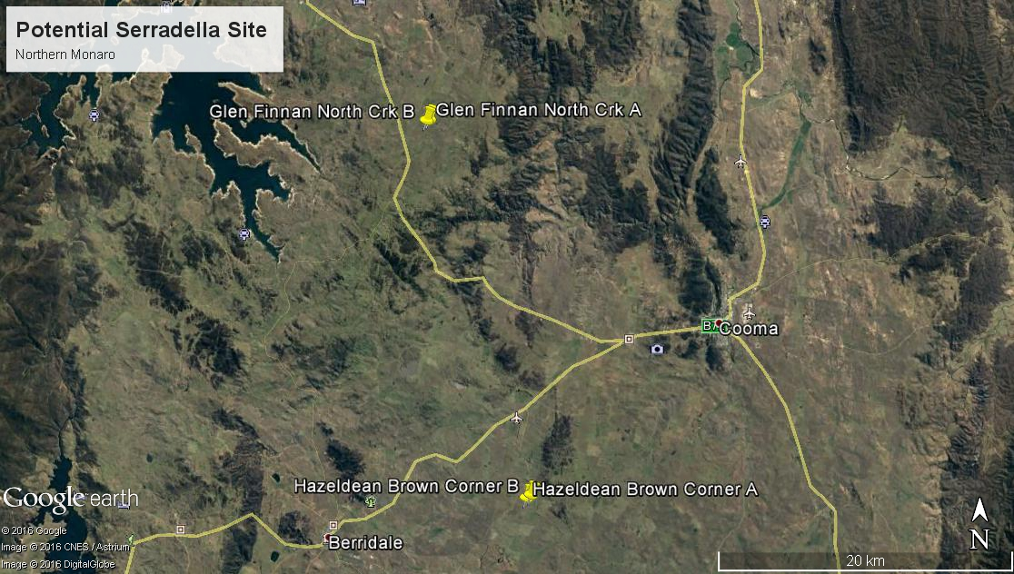

Map of potential southern sites.
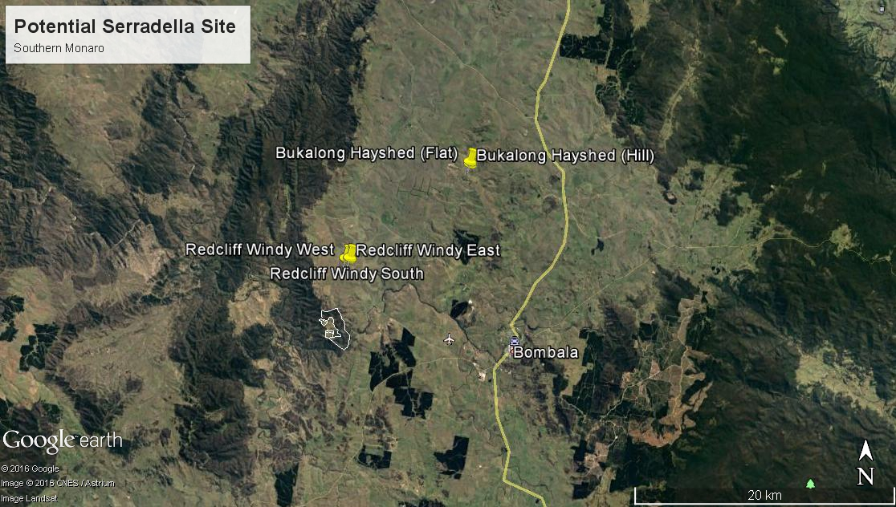

Map of selected northern site (Glen Finnan)
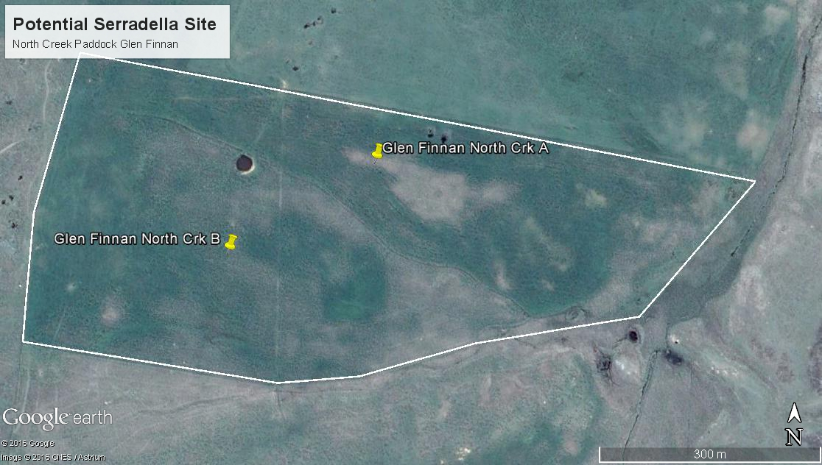

Map of selected southern site (Redcliff)
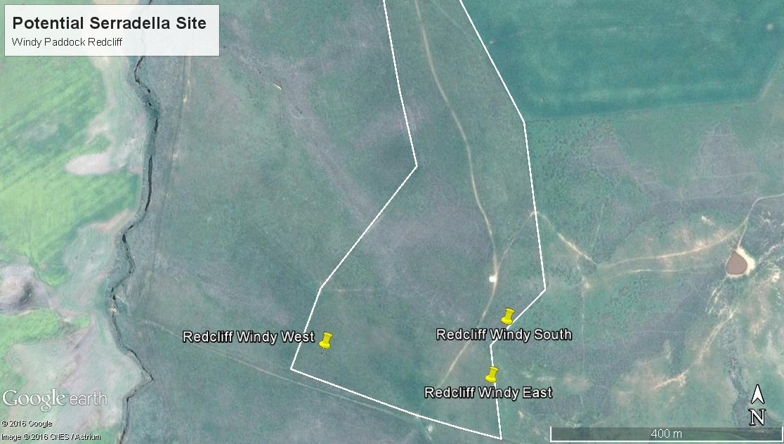

Preliminary Soil Test data for the sampled sites
 |  |  |  |  | predicted critical Colwell for clover
 | Colwell P | Olsen P | PBI | PBI | predicted critical Colwell for clover
 | mg/kg | mg/kg | colwell | unadjusted
Redcliff windy East | 10.8 | 5.1 | 70.3 | 68.4 | 31
Redcliff windy South | 5.80 | 2.9 | 69.4 | 68.4 | 31
Redcliff windy West | 12.1 | 5.2 | 101 | 98.6 | 33
Hayshed Buckalong Flat | 14.8 | 5.4 | 54.5 | 51.9 | 29
Hayshed Buckalong Hill | 11.9 | 5.7 | 74.3 | 72.1 | 31
Hazeldean Brown Corner Site A | 22.3 | 11.6 | 42.9 | 39.1 | 28
Hazeldean Brown Corner Site B | 24.7 | 10.8 | 54.0 | 49.7 | 29
Glen Finnan North Creek A | 18.1 | 11.4 | 49.6 | 46.5 | 29
Glen Finnan North Creek A POA | 18.6 | 10.8 | 51.3 | 48.1 | 29
Glen Finnan North Creek B | 9.66 | 5.6 | 53.0 | 51.3 | 29
Glen Finnan North Creek B (duplicate of above sample) | 8.60 | 6.4 | 53.2 | 51.7 | 29

